**Feedback Control Systems**

**Lab Report 1**

**Hafiz Ahmad**

**19l-1316**

**Section-6B2**

Study of First Order System

**INTRODUCTION:**

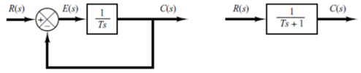In A system with a transfer function that is a first-order differential equation is referred to as a first-order system. A first request differential condition is one which contain single subordinate and no higher subsidiary is involved. In contrast, a system's input-output relationship is its transfer function. The given block diagram depicts a first-order system. First-order systems can be seen in circuits like RC and RL. The following is the general equation for a first-order system: k 1/(s+1) = c(s)/R(s). The system's DC gain is represented by K in the equation, and its time constant is represented by T. If we can figure out the values of K and T in the lab, we can easily figure out the system's transfer function by putting the values in a general equation. We use the system's step function to determine the response.

**OBJECTIVES:**

• To design first order RL and RC circuits and Analyze their Frequency responses.

Equipment Required:

• Oscilloscope with probes

• Function generator

• Digital multi-meter

• Power supply

• Bread Board

• Capacitor, Inductor and Resistor

**Procedure:**

**Task 1:** The RC and RL circuits' step responses are the subject of the first task. We discovered that the value of T is 0.632Vin from the graph. So, we found the value of T at the given value, and we used the equation T=RC to find the value C in the RC circuit from the calculated value of T and the given value of R. Similarly, we first determined the value of T from the step response graph of the RL circuit, and then we determined the value of L by using T=L/R. From the calculated values, we determined the transfer function of the RC and RL circuits, and then we determined the voltage in DB at a different frequency, which we used to plot the asymptomatic Bode plots for the RC and RL circuits.

**Task 2:** To begin the second task, we connected the RC circuit, generated a square wave with 2V p-p from the function generator, measured the output voltages with varying frequencies on the oscilloscope and DMM, converted these values in DB, and then plotted the asymptomatic Bode plots. Similar procedures were followed for the RL circuits.

**Calculations:**

**Task 1:**

As T=0.8 and R=2.2K

For RC Circuit T=RC so C= $\frac{T}{R}$

C=0.8/2.2K => C=0.3636mF

For Transfer Function as Vout= and Vtot=

So, transfer function= $\frac{\frac{1}{sc}}{\frac{1}{sc}+R}$ => $\frac{1}{1+RsC}$ => $\frac{1}{1+0.8s}$

As T=0.5 and R=4.7K

For RL Circuit T= $\frac{L}{R}$ so L=TR

L=0.5(4.7K) => L=2.35KH

For Transfer Function as Vout=sL and Vtot=sL+R

So, transfer function= $\frac{sL}{sL+R}$ => $\frac{2.35Ks}{2.35Ks+4.7K}$

Putting different values of f in the graph as s=jw and w=2*pi*f will produce distinct voltages, and 20Log10(Vin) is used to convert these voltages into decibels.

**Tables:**

**Task 1**

|  |  |  |  |
| --- | --- | --- | --- |
| **Time Constant** | **R=**2.2K | **C=**0.36mF | **T=**0.8 |
| **Time Constant** | **R=**4.7K | **L=**2.350KH | **T=**0.5 |
| **Transfer Function (RC)** | $\frac{1}{1+RsC}$ => $\frac{1}{1+0.8s}$ | | |
| **Transfer Function (RL)** | $\frac{sL}{sL+R}$ => $\frac{2.35Ks}{2.35Ks+4.7K}$ | | |

**Task 2**

|  |  |  |  |  |  |
| --- | --- | --- | --- | --- | --- |
| **Frequency**  **HZ** | **Vin** | **System 1 (RC)** | | **System 2 (RL)** | |
| **Vout** | **Vout (dB)** | **Vout** | **Vout (dB)** |
| **500** | 2 Vpp | 0.99V | -0.087296 | 0.25388V | -11.907 |
| **1000** | 2 Vpp | 0.9735V | -0.23328 | 0.3567V | -8.95393 |
| **2000** | 2 Vpp | 0.9207V | -0.71763 | 0.50269V | -5.97399 |
| **3000** | 2 Vpp | 0.8652V | -1.2576 | 0.614V | -4.2366 |
| **4000** | 2 Vpp | 0.8081V | -1.85069 | 0.6984V | -3.1179 |
| **5000** | 2 Vpp | 0.7513V | -2.4837 | 0.763V | -2.3495 |
| **6000** | 2 Vpp | 0.6970V | -3.13534 | 0.8131V | -1.7971 |
| **7000** | 2 Vpp | 0.6463V | -3.7913 | 0.8505V | -1.4065 |
| **8000** | 2 Vpp | 0.6V | -4.4369 | 0.8792V | -1.1182 |
| **9000** | 2 Vpp | 0.5578V | -5.07 | 0.9012V | -0.90357 |
| **10000** | 2 Vpp | 0.52V | -5.6799 | 0.9183V | -0.7403 |

**Graph:**

**Task 1**

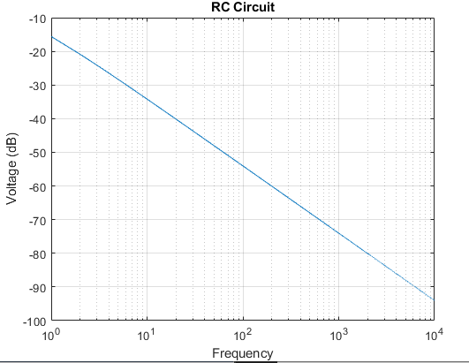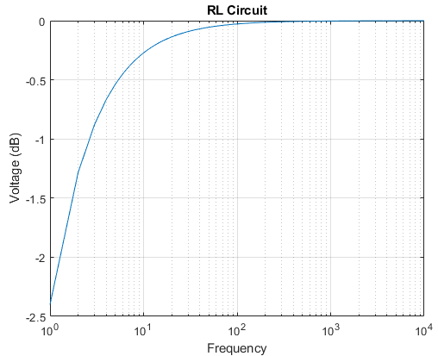

**Task 2**

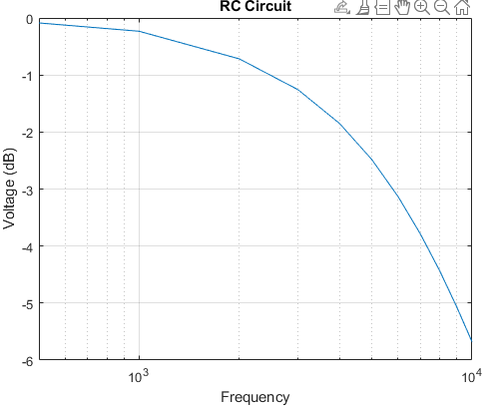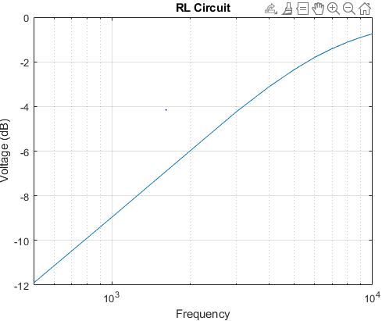

**Compare asymptotic and actual frequency response of both circuits?**

The asymptotic graph is compressed form of the frequency response because it grows logarithmically, whereas the frequency response is along the y axis. This is the difference between the asymptotic and frequency graphs.

**Application:**

By doing this experiment Because we are capable of designing and analyzing a first-order system, we can assist in resolving systemic issues, and this idea will also be useful in the subsequent labs.

**Issues:**

No issue found while performing the lab.

**Conclusion:**

In this lab we learn the first order RC and RL circuit can be designed and analyzed from this lab.

**Post lab:**

**Q1. For the first order system $G\left(s\right)=\frac{3}{s+5}$ find DC gain K and time constant τ and draw the step response of above first order system.**

**Ans:** **The general equation for a first-order system is c(s)/R(s) =k 1/(s+1), which is comparable to the previous equation, where k=3 and T=1/5. We will use various values of off to calculate the voltage in dB for step response, which will result in the following step response:**

**Q2. Comment on the shape of frequency response of each system. Why is it different from the expected shape?**

**Ans:** **We are taking voltage values in Db, which results in a Frequency Response that is not the expected shape. Instrumental errors can also cause the expected value to differ from the measured value.**

**Q-3: Construct the bode plot on a semi log paper whose transfer function is given by $\frac{10\left(s+1\right)}{s+10}$**

**Ans:** Graph

